**Ideation Phase**

**Define the Problem Statements**

|  |  |
| --- | --- |
| Date | 18th July2025 |
| Team ID | LTVIP2025TMID55874 |
| Project Name | Orderonthego |
| Mentor Name |  |
| Maximum Marks | 2 Marks |

**Customer Problem Statement Template:**

To define the core problems freelancers face while searching for jobs online, and use those insights to guide the development of Freelance Finder.

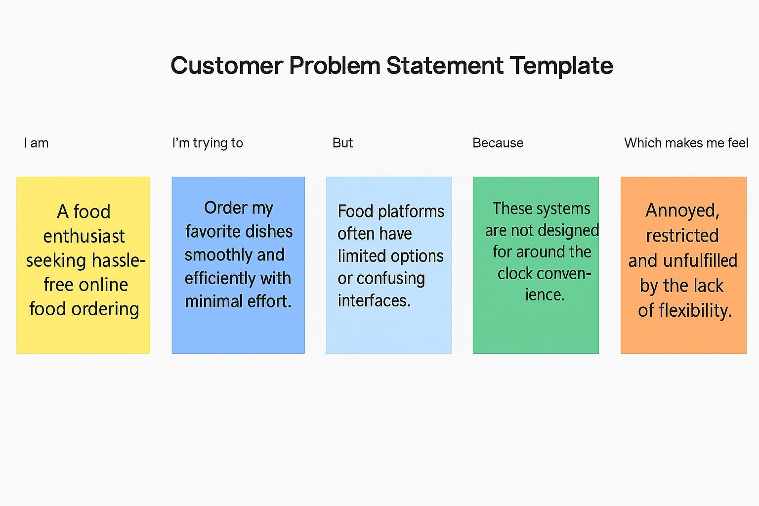

|  |  |  |  |  |  |
| --- | --- | --- | --- | --- | --- |
| **PS ID** | **I am (Customer)** | **I’m trying to** | **But** | **Because** | **Which makes me feel** |
| **PS- 1** | a busy professional with limited time | order food quickly without long wait times or hassle | most food delivery apps don’t show real-time delivery status or accurate restaurant availability | their systems are outdated or fragmented | frustrated and hungry while waiting |
| **PS- 2** | a local restaurant owner | manage incoming orders efficiently and reduce cancellations | my current order management is manual or not integrated with delivery platforms | I can’t afford or understand complex restaurant software | stressed and overwhelmed despite working hard |